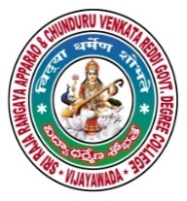 | SRR & CVR GOVERNMENT DEGREE COLLEGE  (AUTONOMOUS)  VIJAYAWADA, KRISHAN DIST., A.P  NAAC B+GRADE(CGPA:2.60) | 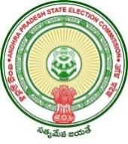

VISHWANADHA JAYANTI
Date: 10-9-2020
- Viswanadha jayanti celebrations on SRR & CVR college (A), Vijayawada

- Resource person: Hod’s of Telugu and Political scienc and respected Lecturers .

- Chief Patron: Principal Dr.Illa Ravi.
Vishwanadha jayanthi was held at SRR & CVR GDC(A), VJA College. On this occasion, the Principal Dr.Illa Ravi spokes on the importance of this occasion and commemorated the sacrifices of Vishwanadha Satya Narayana to society. Incharges of Telugu and Political science were present.

